Explore Europe

***Project Report***

**Web Technology - CIS 435 - Fall 2020**

Team Members:

Brendan Batchelor

Alex Navarre

Alexander Rosati

|  |
| --- |
| **Table of Contents** |

1.0 Project Overview 3

1.1 Project Description 3

1.2 Design Considerations 3

1.3 UI Mockup 3

1.3.1 list.php 3

1.3.2 country-info.php 4

1.3.3 map.php 4

2.0 Group Members & Responsibilities 5

2.1 Brendan Batchelor 5

2.2 Alex Navarre 5

2.3 Alexander Rosati 5

3.0 System Components 5

3.1 Page Breakdown 5

3.1.1 list.php 5

3.1.2 country-info.php 5

3.1.3 map.php 5

3.1.3.1 Functionality Breakdown 6

3.1.4 404.php 6

3.2 API 6

3.3 UML Diagram – Activity Diagram 7

4.0 Tutorial 8

4.1 Project Structure 8

4.2 XAMPP – htdocs 8

4.3 Navigating to the Main Page 9

4.4 Using the Website 10

5.0 Appendix 12

5.1 Appendix A – Testing 12

5.1.1 Browser Testing 12

# Project Overview

## 1.1 Project Description

Our goal was to create a website that gave the user access to information on all the European countries. The user will be able to select any country given they would like to learn more about. There will be a list clickable country names and an interactive map that will both take the user to the correct display page with information about each countries capital, subregion, population, latitude, longitude, and all the bordering countries.

## 1.2 Design Considerations

The project uses HTML/CSS/JavaScript for the front-end portion and uses and PHP for the back end. API calls are utilized to retrieve information from each country from <https://restcountries.eu/>. The webpages are all hosted locally through XAMPP. The Apache server is used to handle the PHP portions of the webpage.

## 1.3 UI Mockup

### 1.3.1 list.php

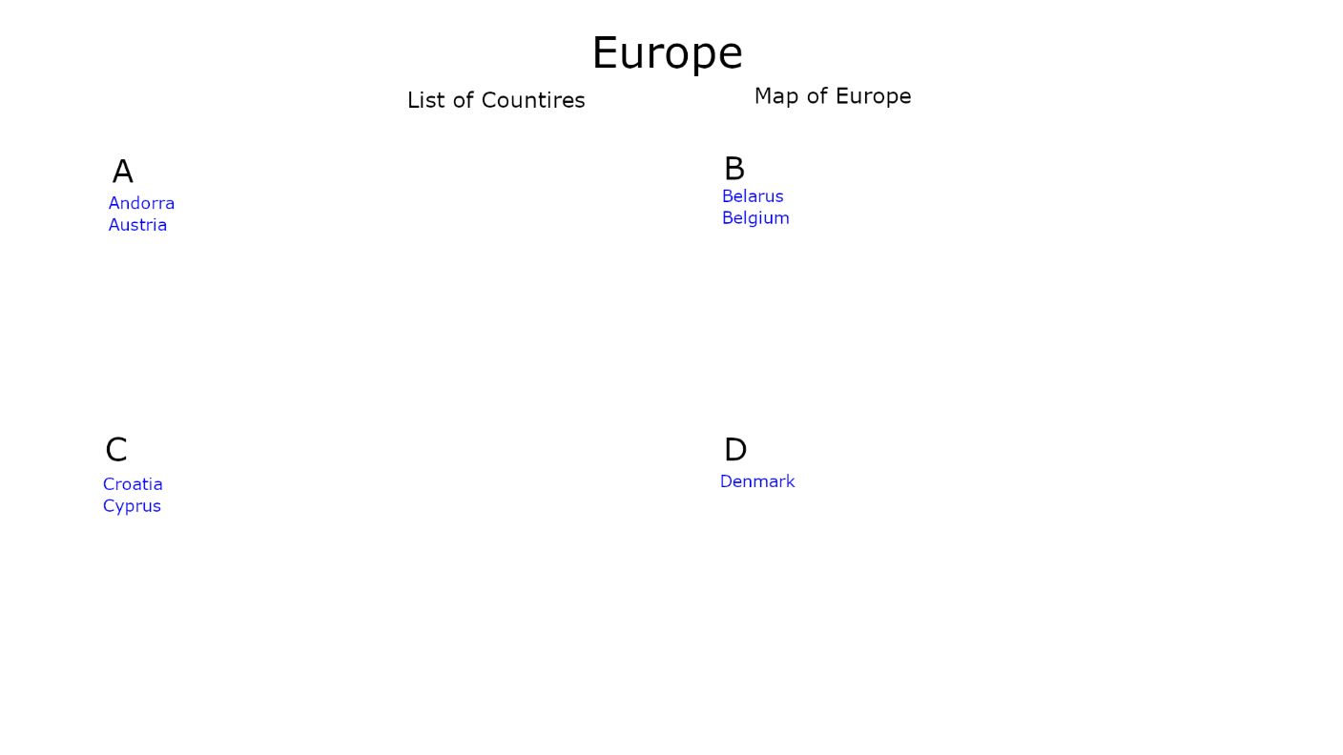

### 1.3.2 country-info.php

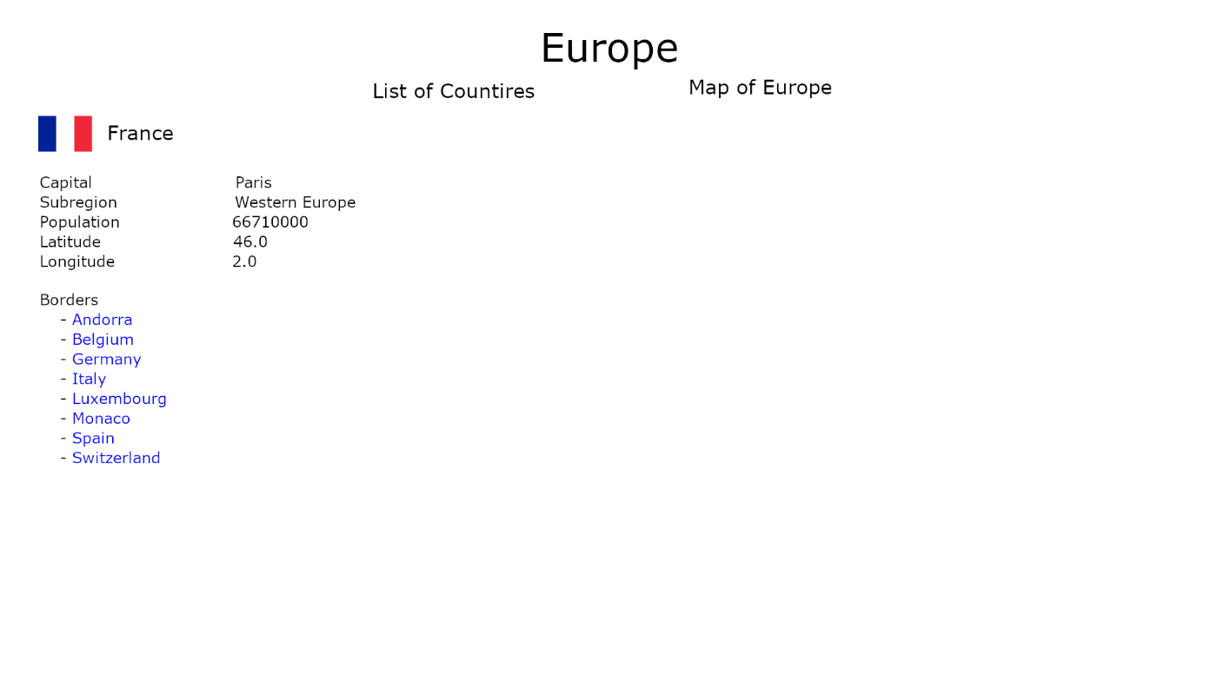

### 1.3.3 map.php

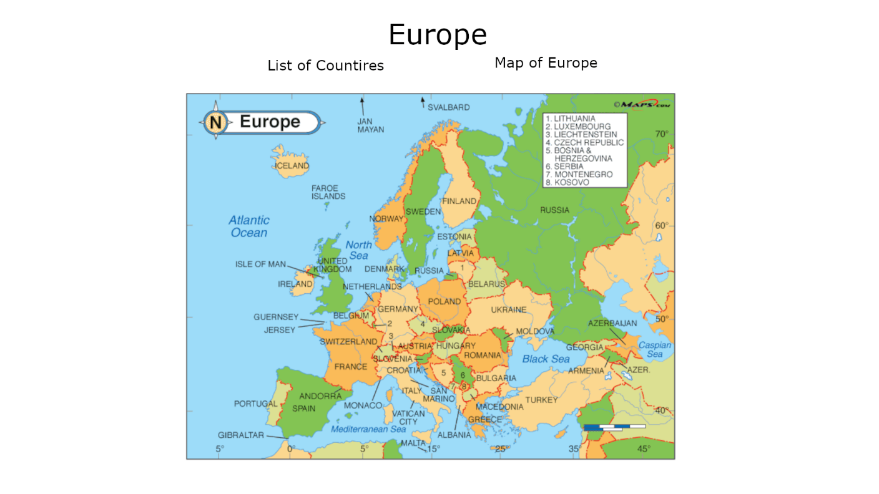

# 2.0 Group Members & Responsibilities

## 2.1 Brendan Batchelor

* CSS Styling
* map.php
* Project Submit

## 2.2 Alex Navarre

* 404.php
* Report
* Tutorial
* Testing

## 2.3 Alexander Rosati

* country-info.php
* header.php
* UI Mockup

# 3.0 System Components

## 3.1 Page Breakdown

### 3.1.1 list.php

The list file acts as our landing page. The page begins by grabbing all the country codes listed in the JSON file, country-codes.json, and then arranges them into alphabetic groups. After the countries are separated into their respective categories, the groups of countries are printed in the correct order and are given form links with their corresponding country codes. The API calls are used to gather the information displayed on the country-info page.

Erroneous country codes used in the API call will result in the user being sent to the 404-error page.

### 3.1.2 country-info.php

The country info page displays information about the selected country and is gathered from the API. The user can navigate to this page by selecting a country from the country list page or by clicking on a country while on the maps page. The information displayed to the user is:

* Capital City
* Subregion of Europe
* Latitude
* Longitude
* Bordering Countries

### 3.1.3 map.php

The map page displays an interactive map of Europe that the user can use to visit the corresponding country-info page. The page uses a mix of HTML, JavaScript, and PHP to achieve this goal. Each country image is sent to a canvas object and is oriented to mimic a map of Europe.

The external JavaScript file, mapHandler.js, takes the HTML images and:

* Draws them all onto canvas in the correct orientation
* Keeps track of which pixels are occupied by which country
* Handles the mouseover/click events to determine which country is hovered or selected
  + Hovering over a country displays the country name below the map
  + Clicking on the country image takes the user to the corresponding country-info page

#### 3.1.3.1 Functionality Breakdown

The page begins by making an API call to retrieve all the country codes. After that, the function that “draws” the map is called and it uses stored images and country codes to build the interactive map and assign the correct codes to their respective country images. Finally, a hover and onclick handlers are assigned and are used to display the hovered country and send the correct form to the country-info page.

### 3.1.4 404.php

This page serves as a landing point to an incorrect API call. If a user enters in an incorrect country code in the URL, it will send them to this page. It displays and error message and gives a link back to the main list page. The page is displayed if the API is being sent a code that is not found within the country code list found in the JSON file.

## 3.2 API

The API that we used for this project is called Rest Countries. It has many rest endpoints that give information about all the European countries. We used modified $_GET requests that corresponded to the selected country from the list or map page to create URLs to hit the right endpoints. The data is stored locally and then displayed to the user. A URL with an incorrect country code sends the user to the error page.

## 3.3 UML Diagram – Activity Diagram

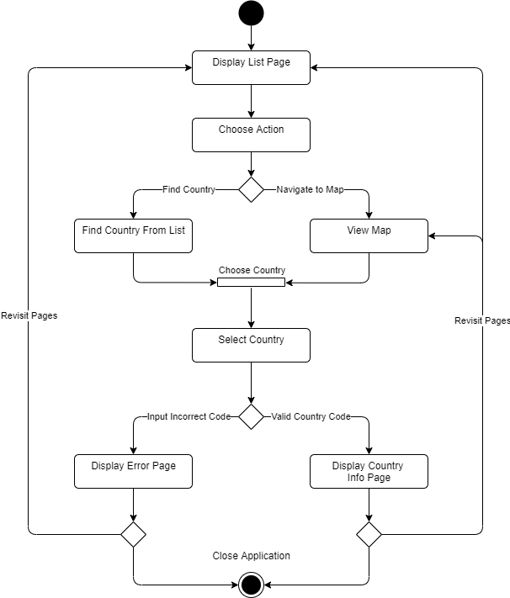

# 4.0 Tutorial

## 4.1 Project Structure

* The entire project is in the “expeur” folder
* All the required HTML, CSS, JS, and PHP files necessary to run the webpages are found in this folder

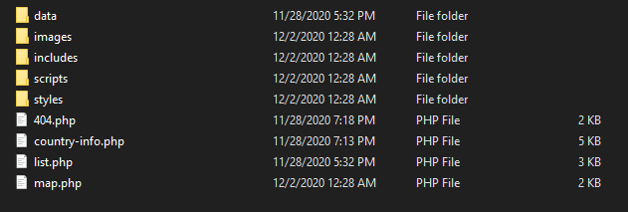

## 4.2 XAMPP – htdocs

* The project is hosted locally using XAMPP and its Apache Server.
* The user should install XAMPP and then move their “expeur” folder in the htdocs folder

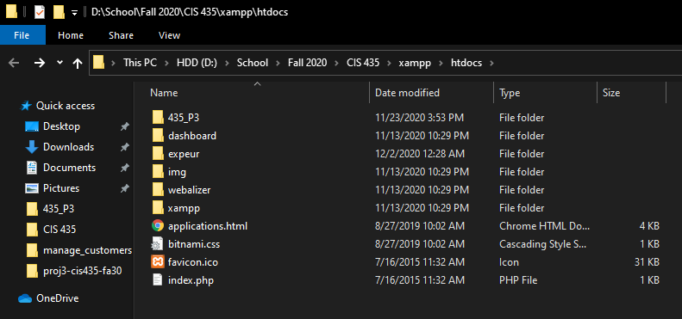

* After the folder is in the correct directory, the user should run XAMPP and start the Apache server

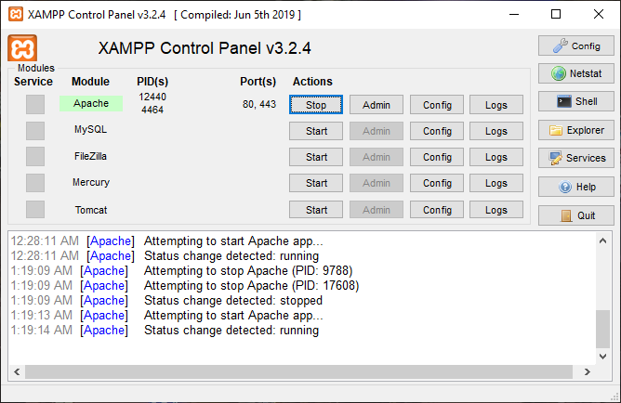

## 4.3 Navigating to the Main Page

* To reach the main page, open your preferred web browser and navigate to the following URL:
  + - Localhost/expeu/list.php

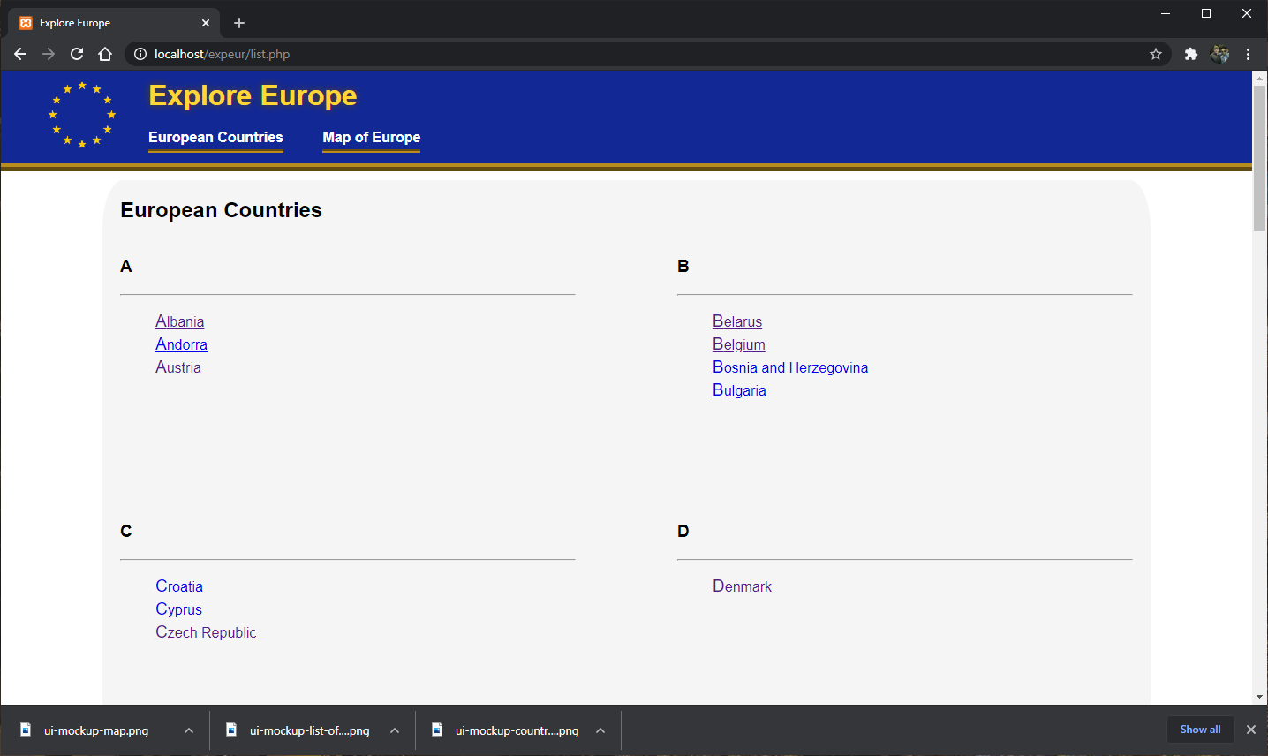

## 4.4 Using the Website

* From the list page, the user can find more information about the countries by:
  + - Clicking on a link that is listed on the list page

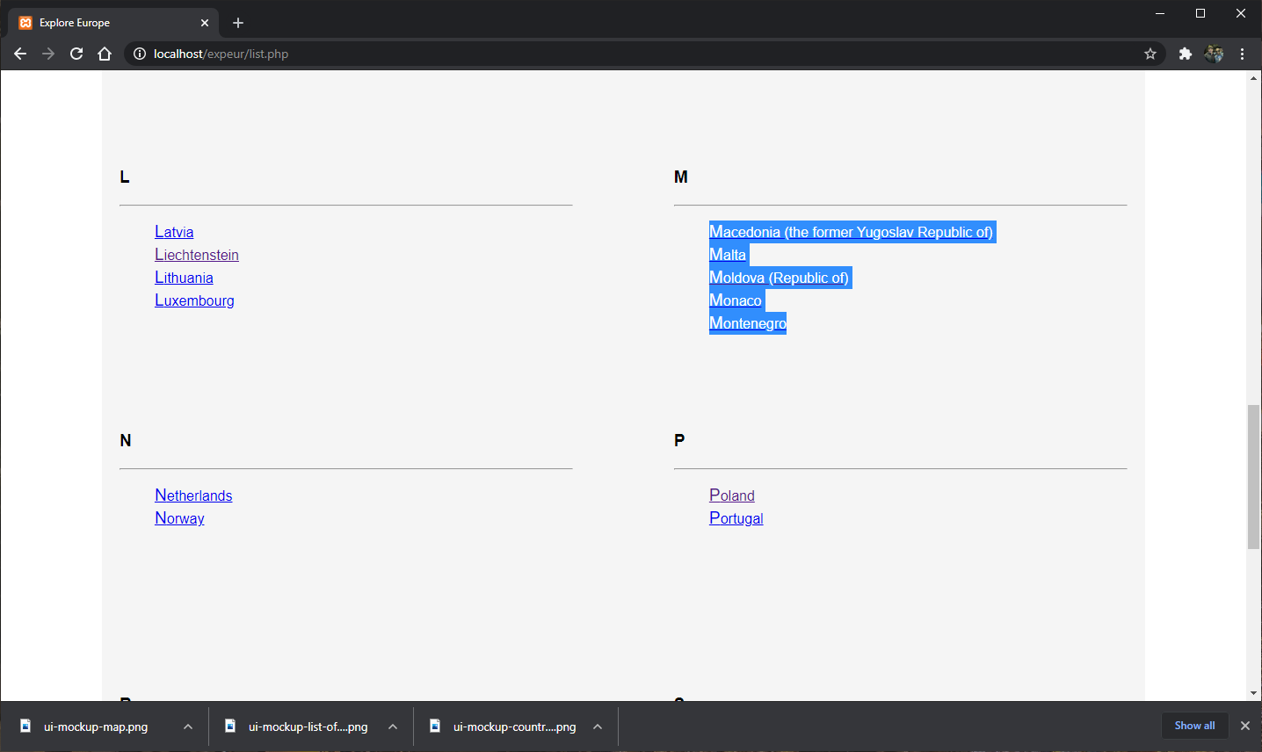

* + - Navigating to the “Map of Europe” page and clicking on the corresponding country

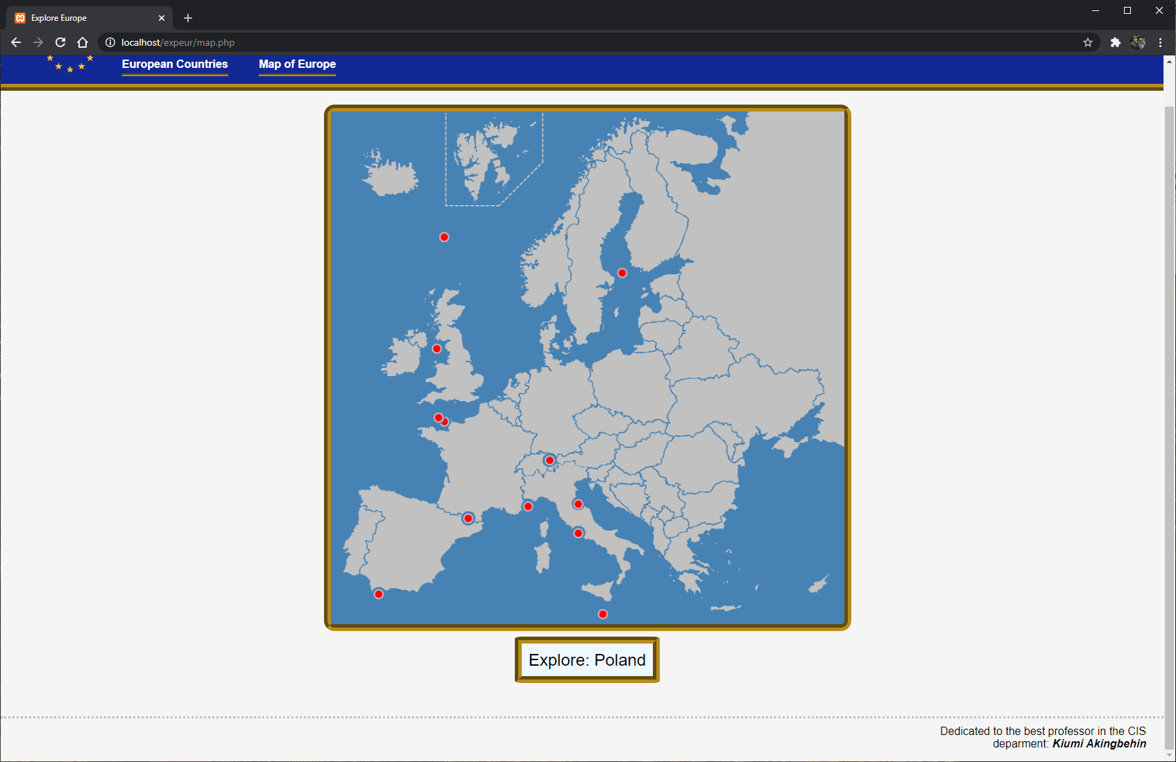

* Both actions will take you to the country information page

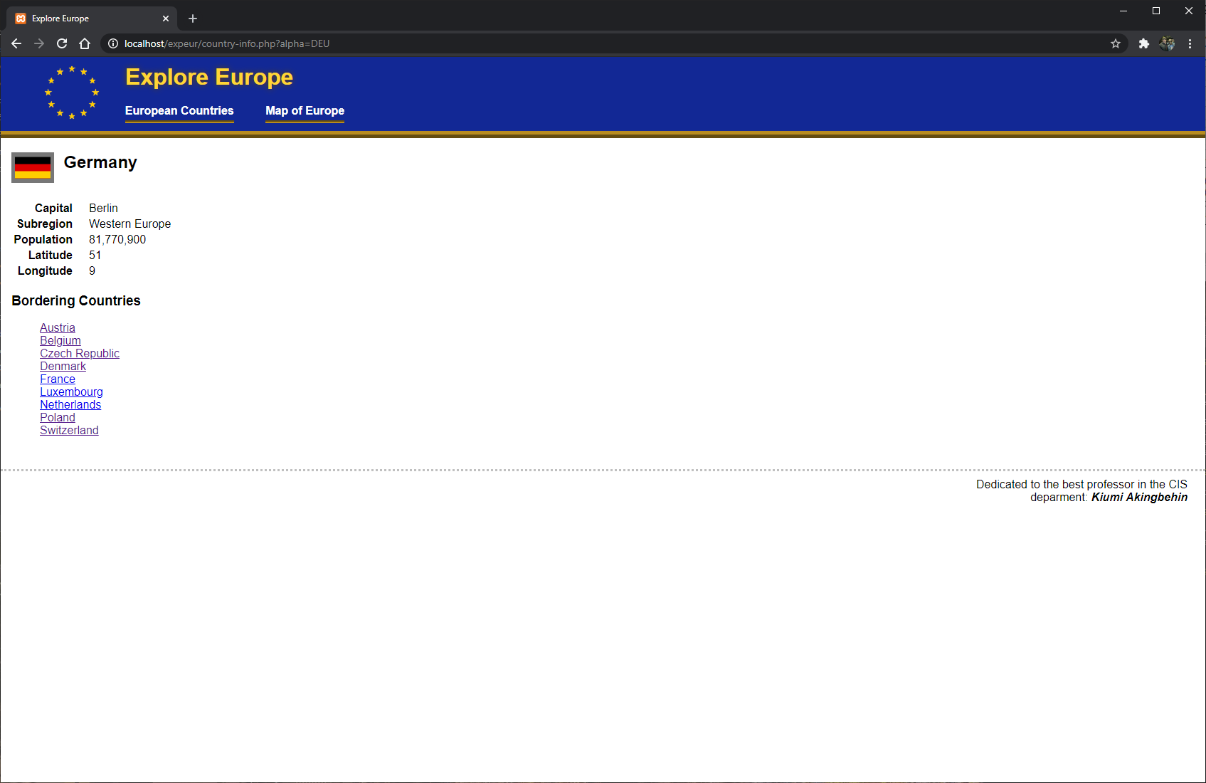

* Changing the country code in the URL to an invalid code will take you to the error page

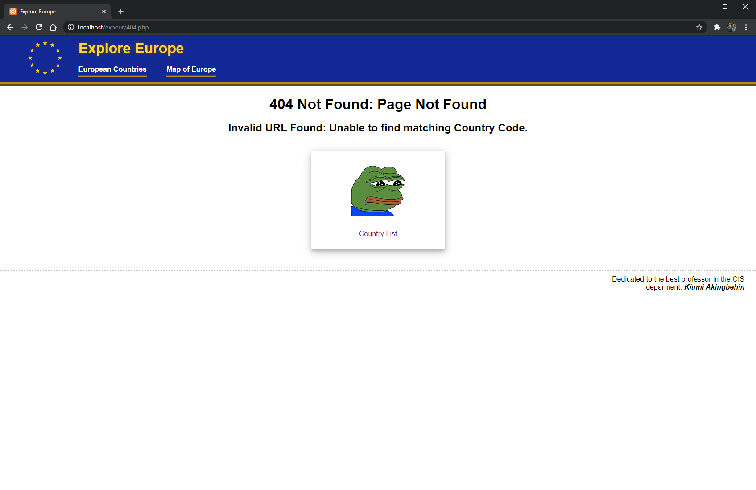

# 5.0 Appendix

## 5.1 Appendix A – Testing

### 5.1.1 Browser Testing

We performed simple browser tests using Chrome, Firefox, Edge, and Opera to make sure all of our pages preformed as intended. The following screenshots are of the country list, map, country info, and error pages.

